Data & Telemetry Off-Track Award supported by Schmid Elektronik
The following are the details for the 2022 Data & Telemetry Off-Track Award as described in the Shell Eco-marathon 2022 Official Rules, Chapter 1. Visit https://www.makethefuture.shell/en-gb/shell-eco-marathon/2022-programme/virtual/off-track to learn more about the other categories available on the 2022 Virtual Off-track Awards.
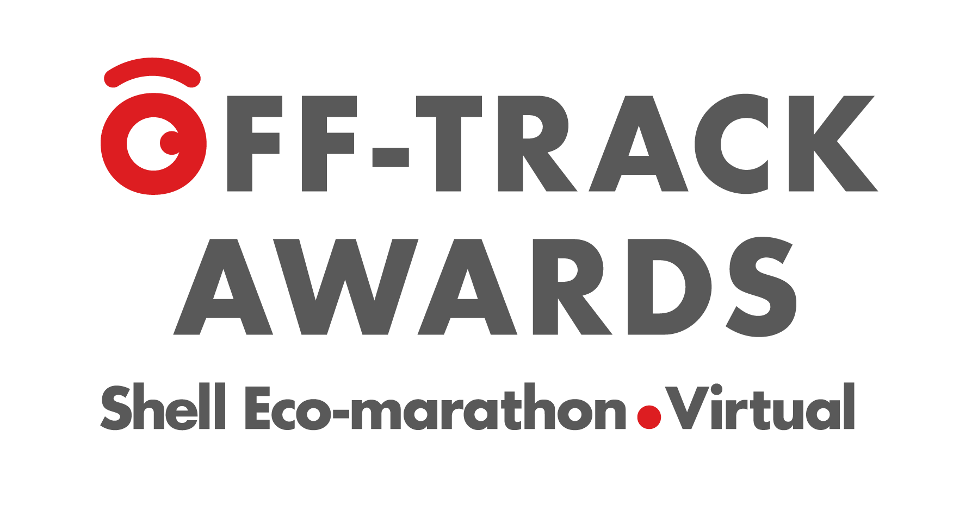

Overview
This prize recognises the conceptual or actual design of intelligent information and knowledge processes from real-time or close to real-time vehicle and race data. This will lead to a competition that:
- follows a data-driven and digitised approach,
- innovates your race strategy and driving tactics, and
- improves your energy efficiency and track performance in the Mileage Challenge.
The award is open to both Prototype and Urban Concept Teams. The referenced vehicle data can be from the existing Shell telemetry system (as described in Section 5 of Chapter I), from a Team’s existing telemetry system or data from a fully conceptual telemetry system. Answers to the following five questions will be used in judging the submissions:
1. Data Points: How does your data strategy look like and what vehicle sensor data (e.g. vehicle speed, energy usage) and context data (e.g. track map) do you identify as relevant to support the above three goals?
2. Information Processes: What race related patterns, coefficients and control parameters do you extract from the data (1) and which information/knowledge processing (analysis, modelling, simulation, machine learning) do you use to achieve the appropriate control strategy that keeps the vehicle close to the optimum in the context of the given driving situation and subject to the above mentioned contest goals?
3. Strategy Development: What is your overall race strategy and how to you use the understanding, knowledge and insights from (2) to make it data-driven, smart and adaptive?
4. Driver’s Performance: Which clues and/or previews will emerge from (3) and how to they support the driver’s decision making, intelligent manoeuvres, specific driving situations and/or edge cases?
5. Results Improvement: Does your data-driven approach (1 - 4) reduce your energy consumption, increase your speed or even both? What will be the outcome, how much of an improvement in [%] do you expect and why? Please provide supporting analysis.

Objective
Teams must answer the five listed questions and explain how expected outcomes relate to an improvement of their energy efficiency, track and Team performance and benefit Shell Eco-marathon. Participants are encouraged to think outside the box and pursue also unconventional and disruptive ideas.

How to participate
Application for this award is voluntary. Teams wishing to participate must submit design documentation in pdf format. The report should consist of an executive summary and a technical description covering item 1-5. The design documentation must not exceed 1,500 words, using a minimum font size of 10 points, and 10 pages; images, screenshots, graphs, tables and drawings do not count towards the word count but must still respect the maximum number of pages.

Webcast
Two webcasts were held in 2021 to familiarise you with the Data & Telemetry Off-track award, share how to make the most of the data collected from your vehicle and how to use that information to your advantage during the on-track competitions.
Recordings from both sessions are now available on youtube. The presentation content is the same but there were different questions asked - we encourage you to listen to both sessions' questions.
- February 3, 2021 at 15:00 GMT 👉 https://youtu.be/79L3p9SWyYc
- February 3, 2021 at 05:00 GMT 👉 https://youtu.be/GWmSZzdxo8M?start=2642

FAQ
As part of each of the webcasts, a question and answer session was held. Below are a list of the most common questions and their respective answers that were asked during the webcast Q&A. Any further questions should be addressed to your regional Shell Eco-marathon Email address.
Q: Can a team with a prototype vehicle participate in the Data and Telemetry Off-Track Award?
A: YES, the off-track award is open to Prototype teams as well as Urban Concept teams. A Prototype team may submit the required design documentation for the Data and Telemetry Off-Track Award.
Q: Does the off-track submittal have to be based on the telemetry data provided by the Shell telemetry equipment?
A: No, a team may use any telemetry data available from a conceptual telemetry system. A team may use all, part, or none of the data provided by the Shell telemetry system.
Q: If a team uses its own telemetry system for testing and optimization purposes in their trials to prepare for the competition, would it be something you want to see included on the award submission?
A: The off-track award submission should address the questions listed in the award description. Teams are free to address those questions in any method they choose. The is NO REQUIREMENT for a team to have their own telemetry system to submit to the off-track award.
Q: Are we allowed to use our own telemetry systems and other forms of data for the concept for this award?
A: YES, teams can design a system to use data/parameters for their own telemetry system or a conceptual system that has not yet been built.
Q: Where can I get information about existing telemetry data?
A: Please look at the Team Telemetry Data section.

