Joulemeter (JM2)
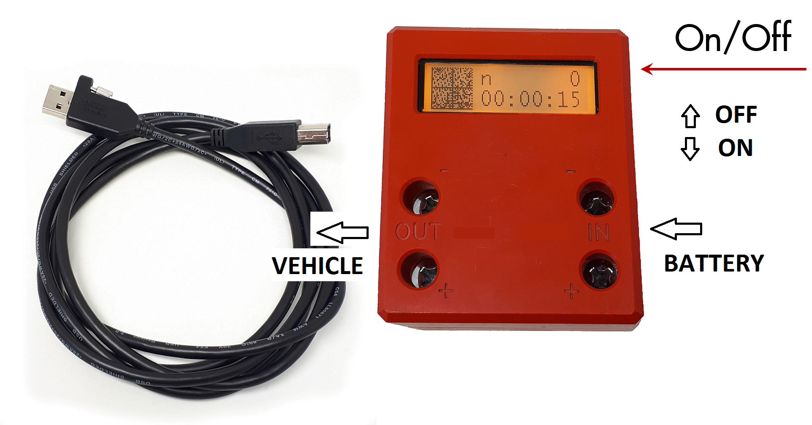

Description
The joulemeters used in the Shell Eco-marathon (Shell Eco-marathon) are custom built for Shell and are not available for purchase. The joulemeter (JM) measures voltage across the + and – bus bars and current through one of the bus bars. The JM calculates joules from measure of voltage, current, and time. The JM will be used in all Shell Eco-marathon energy classes to measure electrical energy flow. The JM includes a LCD display showing a number of measured values. Firmware in the JM measures the following;
- Positive and negative joules,
- Totalized joules,
- Total number of starter motor activations (ICE vehicles),
- Total starter run time (ICE vehicles), and
- Totalized starter joules (ICE vehicles).

Characteristics
Weight | 550g (1.21lbs)
Dimensions | 88mm wide x 108mm tall x 46mm depth (3.5” x 4.25” x 1.8”)
Voltage range | + 0 to 60 VDC
Current range | +/- 0 to 300 A
Resistance of shunt | 100 µΩ
Voltage measurement resolution (internal) | 2 mV
Current measurement resolution (internal) | 10 mA
Joule display resolution | 1 J
Shunt internal temperature compensation | yes

Drawings and Dimensions
Front view | Left side view
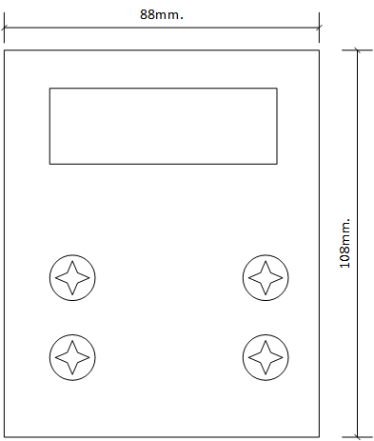 | 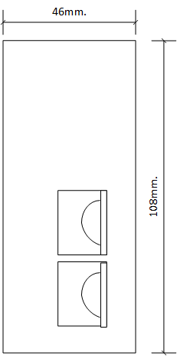

Installation before event
NON Battery Electric Prototype vehicles are not currently required to install a joulemeter.
Joulemeter location in vehicle and other considerations (Chapter 1 - Article 56)
- Prior to arrival at the event, teams should identify a location to accommodate the Joulemeter near to the battery.
- The display of the Joulemeter must be visible when looking into the engine compartment.
- The Joulemeter may be secured with cable ties, Velcro or other suitable method.
- The Joulemeter “On” switch located on the side of the Joulemeter must be accessible.

Installation at event
- Disconnect the battery from the vehicle electrical system.
- Using the provided spade lugs or equivalent, connect the positive and negative leads in and out of the Joulemeter.
- Secure the Joulemeter with Velcro or cable ties ensuring the display is visible and the on/off switch is accessible.
- Reconnect the battery to the vehicle electrical system.
- Where equipped, connect the USB cable to the Joulemeter and the On-Board Computer (OBC) USB. You MUST NOT use your own USB cables. Use the cable provided, it electrically separates the JM from the On-Board Computer.

ICE
The Joulemeter should be installed between the vehicle’s starter battery and the vehicle’s electrical system. As shown in the figure below, both the positive and negative battery leads pass through the Joulemeter.
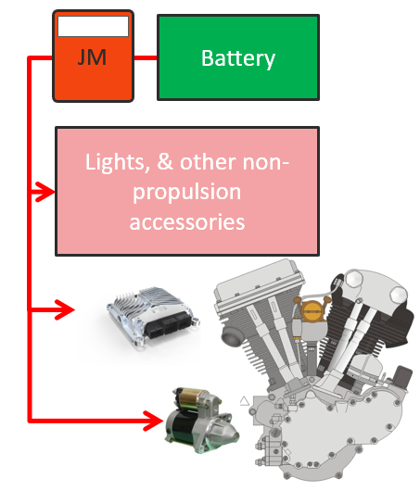
Joulemeter electrical installation (ICE)

BE
For urban concept vehicles the joulemeter should be installed between the battery and the motor controller. As shown below, both the positive and negative battery leads pass through the Joulemeter.
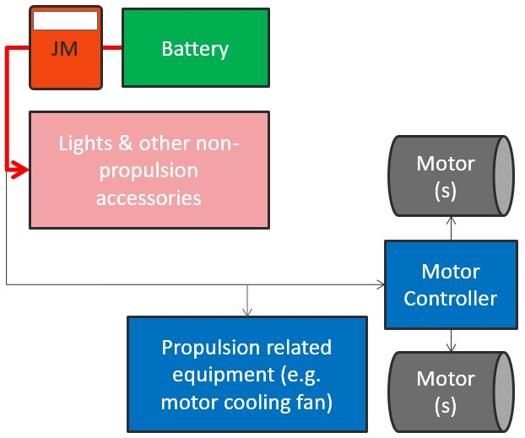
For prototype vehicles the joulemeter should be installed between the vehicle’s electrical system and the propulsion motor controller. As shown below, both the positive and negative battery leads pass through the Joulemeter.
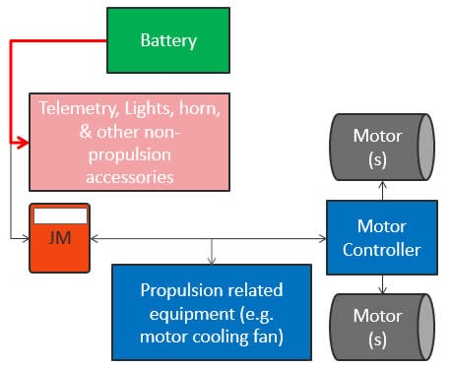

H2
The Joulemeter should be installed between the battery and the vehicle’s electrical system. As shown below, both the positive and negative battery leads pass through the Joulemeter.
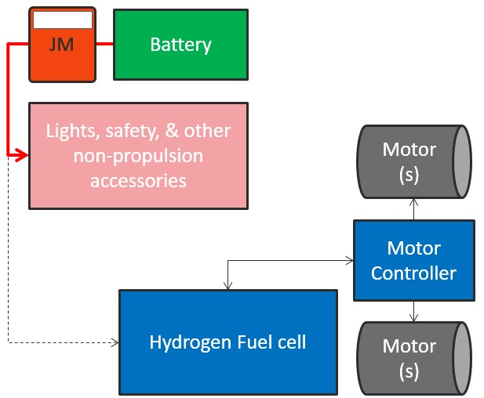

Operation
To operate the JM, turn the on switch to the on position (Down - ON, up - OFF). As the JM powers up, the internal battery voltage will be displayed. The internal battery voltage range should be between 3.5 VDC and 4.1 VDC. The JM will be supplied to teams configured to display the correct measured values.
The JM internal battery can be charged though the USB type B port on the JM top as shown in Figure 3. The JM will be supplied to the teams charged and should last throughout the event if the JM is being turned off when not in use. In case the battery is depleted, connect the JM to any USB port or charger and the battery will be recharged. Although it is not required, the JM will charge faster if it is turned off for charging. The message “Full” will be displayed on the JM when the internal battery is fully charged.

Trouble Shooting
The table below provides a number of troubleshooting options for cases where anomalies are detected.
Please check the contents of this section before seeking assistance.
Condition | Possible Causes | Solutions
The LEDs remain dark when I press the Start Button on the On-Board Computer | OBC battery is not correctly connected to the Backbone  OBC battery is discharged | Verify battery cable is connected to the Backbone  Charge battery
 | Pod not correctly connected to the Backbone | Check cable and plug

