JM3 for Supercap Measurement
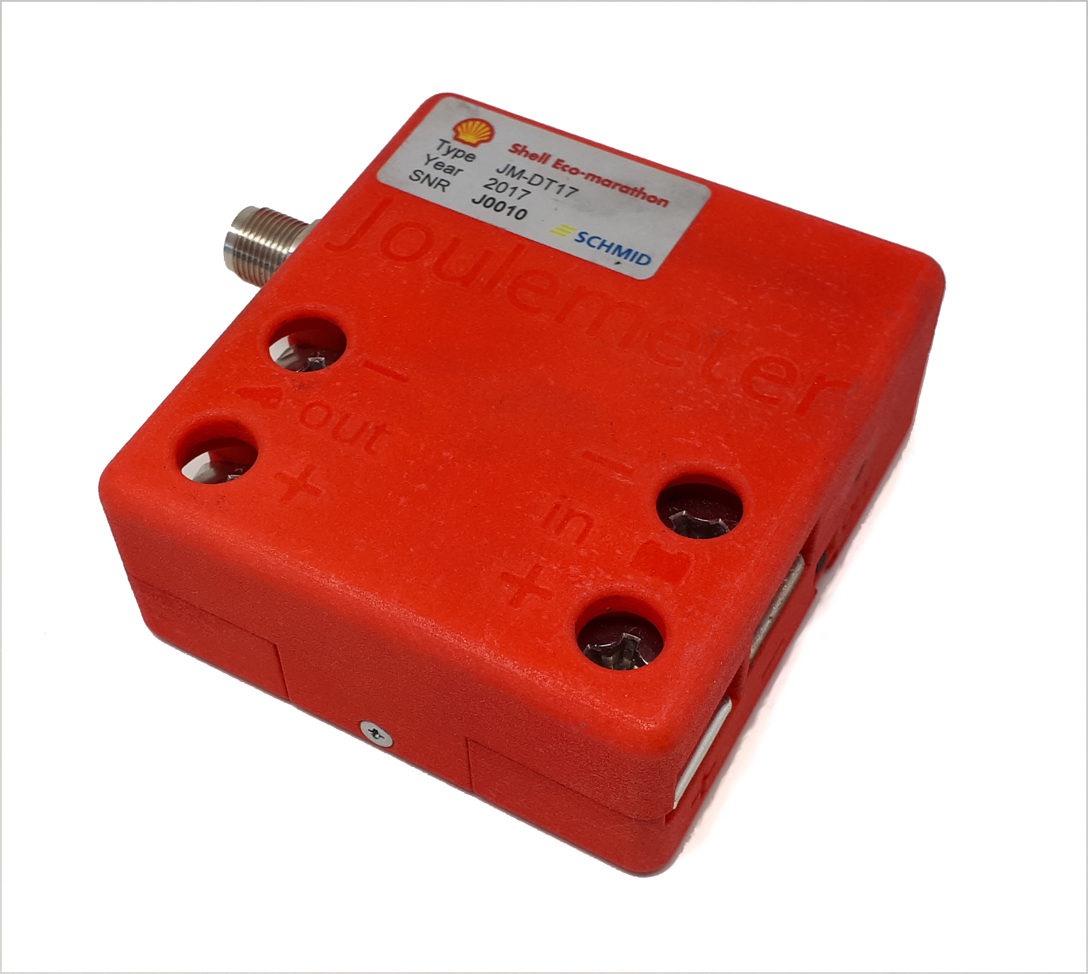

Description
The Voltage of the super capacitor in hydrogen cars will be measured by an additional Joulemeter. It is working the same way as JM3. Since only the voltage gets measured, only the input terminals have to be wired in parallel to the supercap.
The Joulemeters for Supercap measurement are not equipped with a battery and do not need to be charged.

