Telemetry Data Online Logging Instructions
- Log on to your team specific URL by scanning the QR code pasted on the telemetry box or logging on to the URL under the QR code.
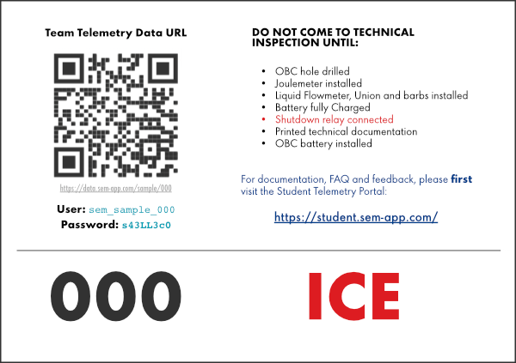Box Label
- Type in your username and your password.
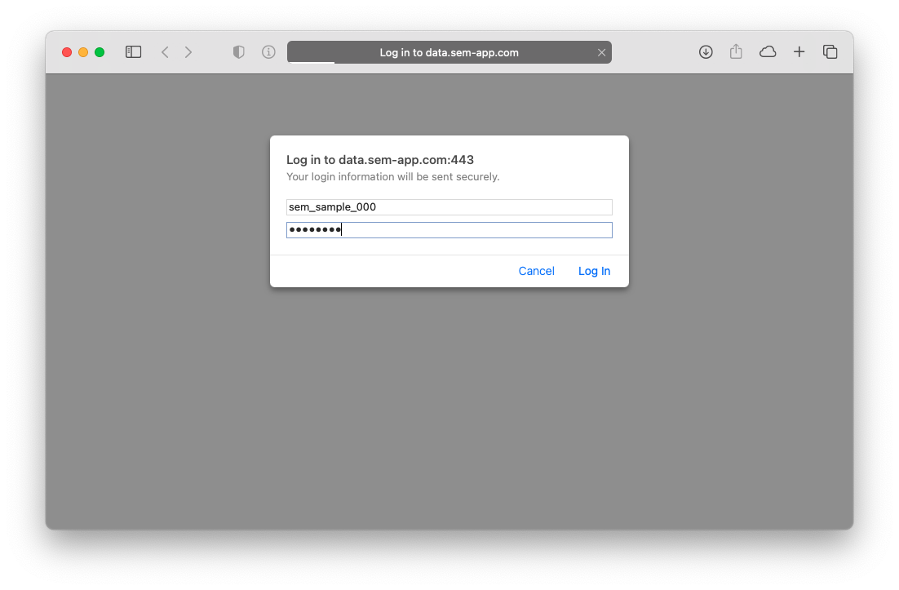Credentials
- Once you put in your username and password you will be logged into your team specific folder.
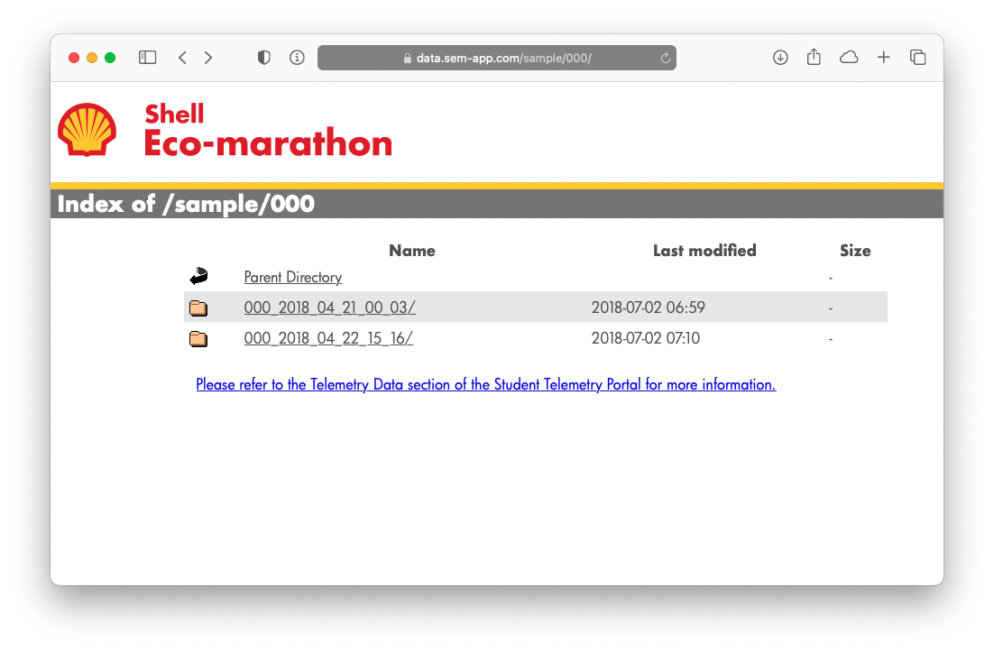Login Page

